Ansible Task 04
- Create ansible playbook to create ansible vault.
cd playbook
Playbook using Ansible Vault
vi vault.yml
---
- name: Create a full Ansible Vault file
hosts: localhost
gather_facts: no

vars_prompt:
- name: vault_password
prompt: "Enter vault password"
private: yes

- name: secret_value
prompt: "Enter the secret value"
private: yes

tasks:

- name: Write vault password to a temporary file
copy:
content: "{{ vault_password }}"
dest: /tmp/.vault_pass
mode: '0600'

- name: Create plain YAML file with secret
copy:
content: |
my_secret: "{{ secret_value }}"
dest: /tmp/plain.yml

- name: Encrypt the plain YAML file into a vault file
command: >
ansible-vault encrypt /tmp/plain.yml
--vault-password-file /tmp/.vault_pass

- name: Rename encrypted file to vault.yml
command: mv /tmp/plain.yml vault.yml

- name: Remove temporary vault password file
file:
path: /tmp/.vault_pass
state: absent

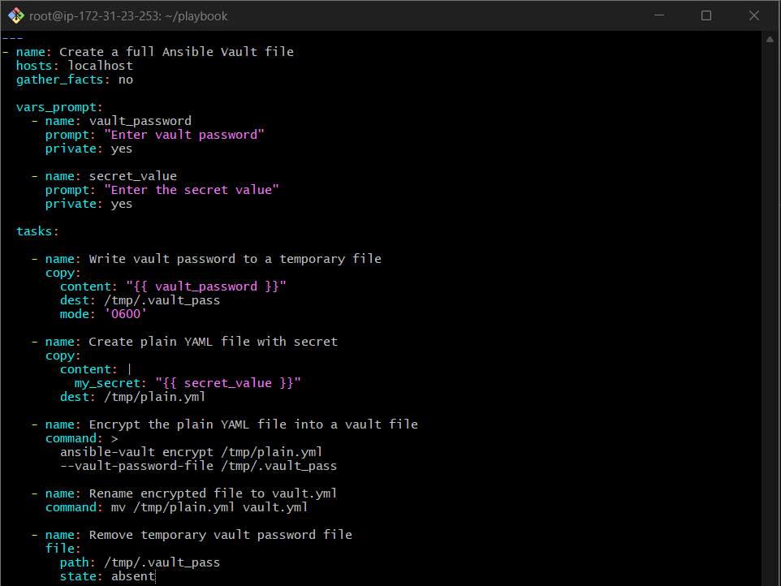
Check the playbook syntax
ansible-playbook vault.yml –syntax-check

Run the playbook
ansible-playbook vault.yml
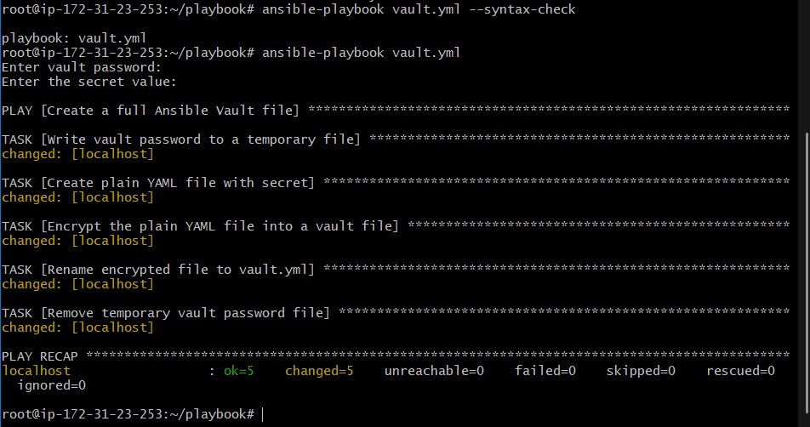
This shows the secret in clear text after you enter the vault password.
ansible-vault view vault.yml

- Write an ansible playbook to install apache in linux and ubuntu machine by using when condition.
Step 1: Create Apache Playbook File
vi apache.yml
---
- name: Install Apache on Ubuntu and RHEL using when
hosts: all
become: yes
gather_facts: yes

tasks:

- name: Install Apache on Ubuntu
apt:
name: apache2
state: present
update_cache: yes
when: ansible_os_family == "Debian"

- name: Install Apache on RHEL/CentOS
yum:
name: httpd
state: present
when: ansible_os_family == "RedHat"

- name: Start Apache on Ubuntu
service:
name: apache2
state: started
enabled: yes
when: ansible_os_family == "Debian"

- name: Start Apache on RHEL
service:
name: httpd
state: started
enabled: yes
when: ansible_os_family == "RedHat"
Save and exit.
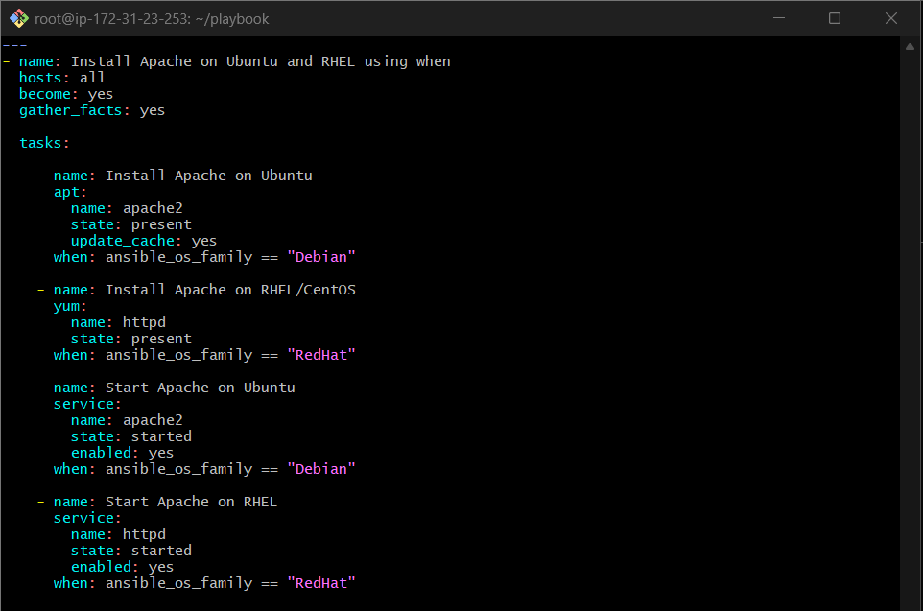
Step 3: Syntax Check the Playbook
ansible-playbook apache.yml --syntax-check

Step 4: Execute the Playbook
ansible-playbook apache.yml
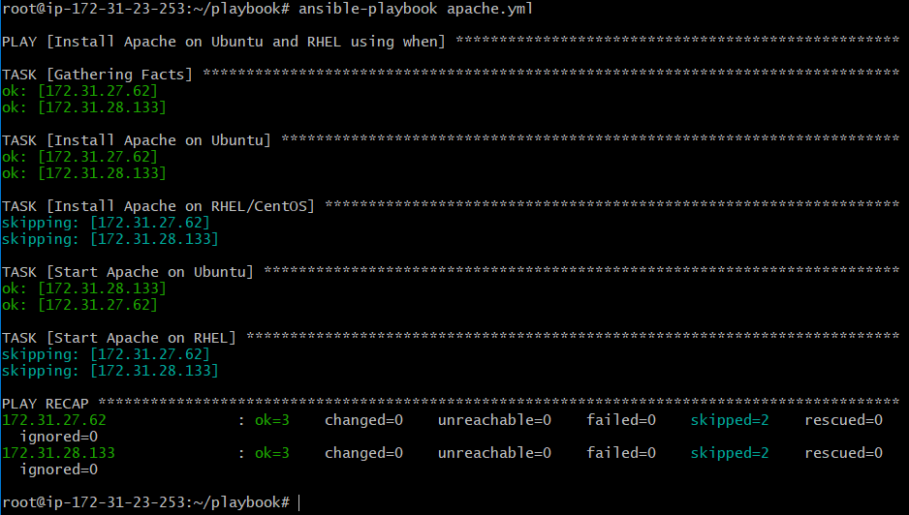
Step 5: Verify Apache Service on Workers
Ubuntu worker
systemctl status apache2
systemctl status httpd
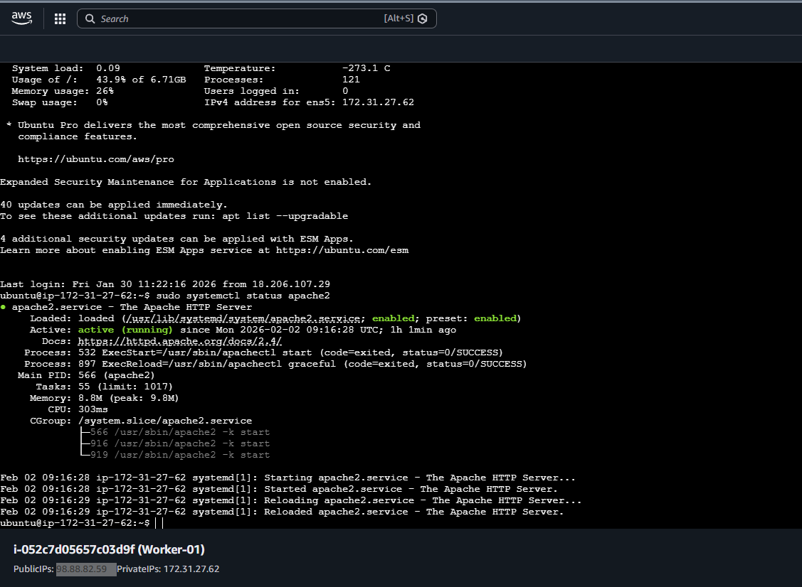
Step 6: Verify from Browser
Open:
http://<worker-ip>
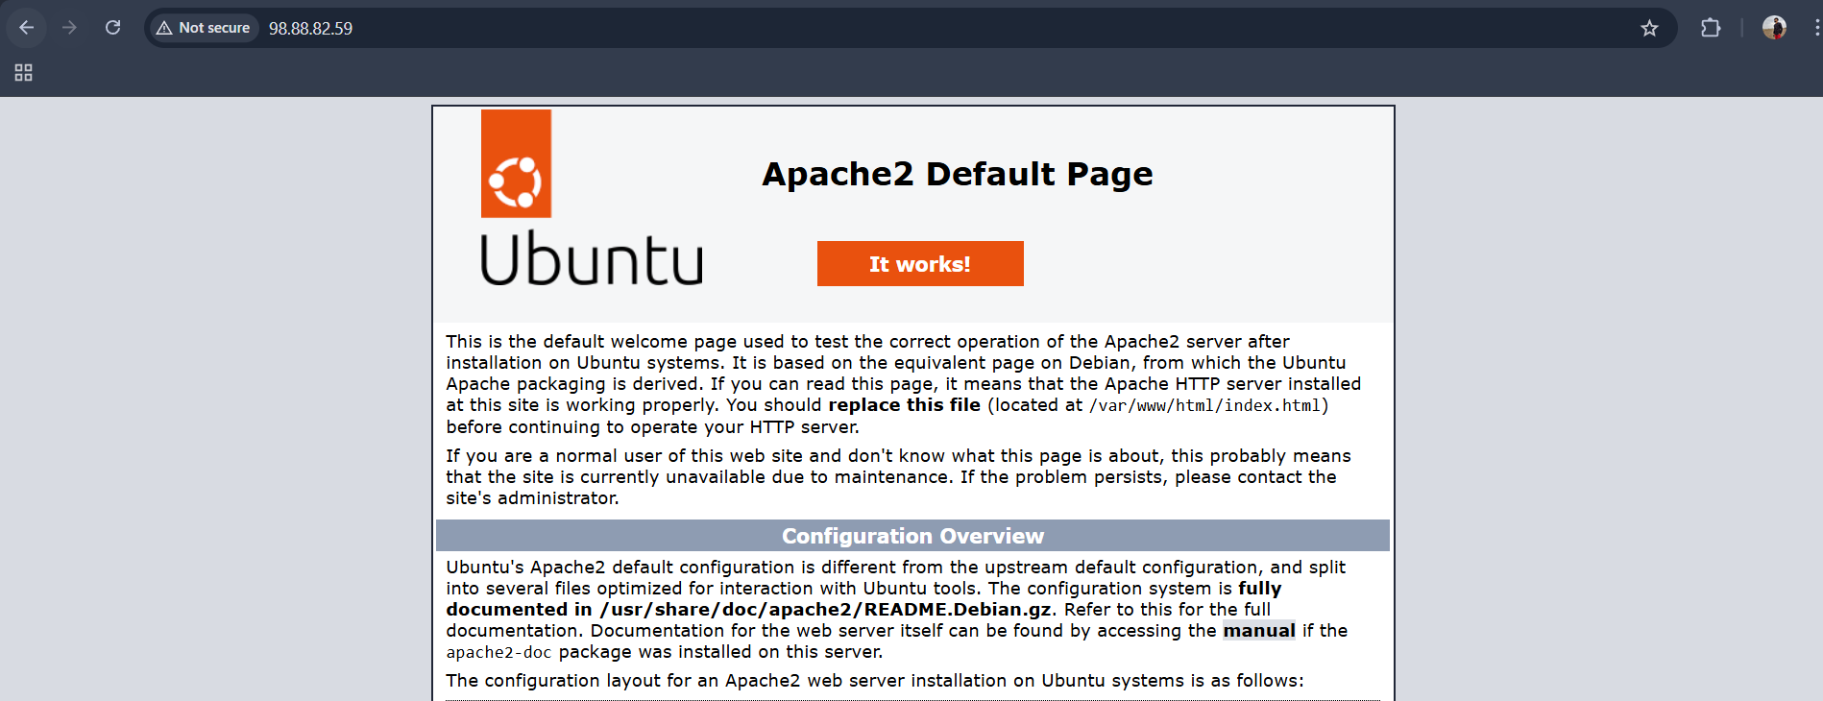

- Create ansible playbook using roles to configure LAMP stack
Step 1: Create Role Directory Structure
From your Ansible controller:
mkdir -p lamp/roles/{apache,mysql,php}/{tasks,handlers}
It creates folders for three roles (apache, mysql, php), and inside each role it creates:
- a tasks folder
- a handlers folder
Folders created
lamp/roles/apache/tasks
lamp/roles/apache/handlers
lamp/roles/mysql/tasks
lamp/roles/mysql/handlers
lamp/roles/php/tasks
lamp/roles/php/handlers
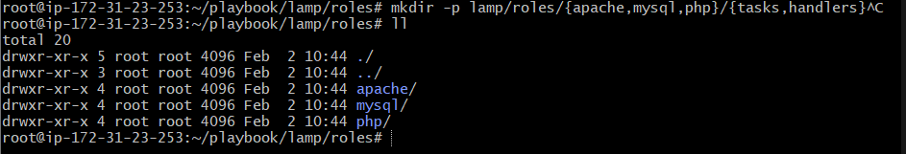
Your structure will look like:
lamp/
├── site.yml
└── roles/
├── apache/
│ ├── tasks/main.yml
│ └── handlers/main.yml
├── mysql/
│ └── tasks/main.yml
└── php/
└── tasks/main.yml

Step 2: Apache Role
roles/apache/tasks/main.yml

---
- name: Install Apache
package:
name: "{{ 'apache2' if ansible_os_family == 'Debian' else 'httpd' }}"
state: present

- name: Start and enable Apache
service:
name: "{{ 'apache2' if ansible_os_family == 'Debian' else 'httpd' }}"
state: started
enabled: yes
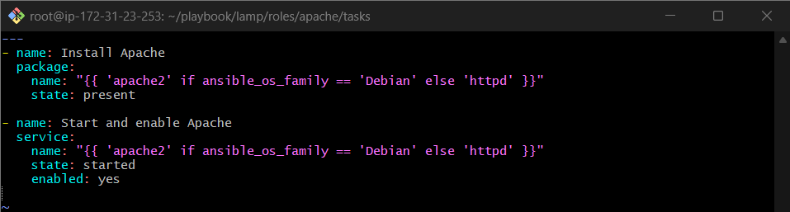
Step 3: MySQL Role
roles/mysql/tasks/main.yml

---
- name: Install MySQL server
package:
name: "{{ 'mysql-server' if ansible_os_family == 'Debian' else 'mariadb-server' }}"
state: present

- name: Start and enable MySQL service
service:
name: "{{ 'mysql' if ansible_os_family == 'Debian' else 'mariadb' }}"
state: started
enabled: yes
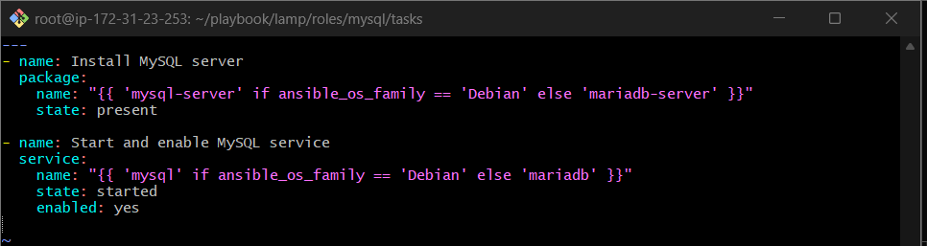
Step 4: PHP Role
roles/php/tasks/main.yml

---
- name: Install PHP packages
package:
name:
- php
- php-mysql
state: present
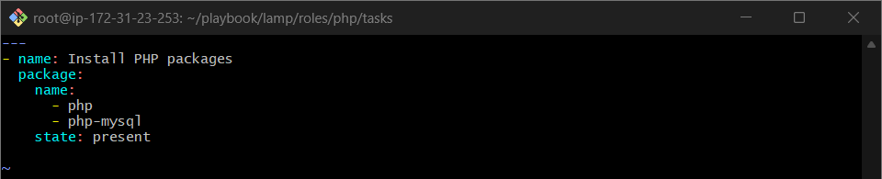

Step 5: Create Main Playbook (site.yml)
cd lamp/
vi site.yml
site.yml
---
- name: Configure LAMP stack using roles
hosts: all
become: yes
gather_facts: yes

roles:
- apache
- mysql
- php
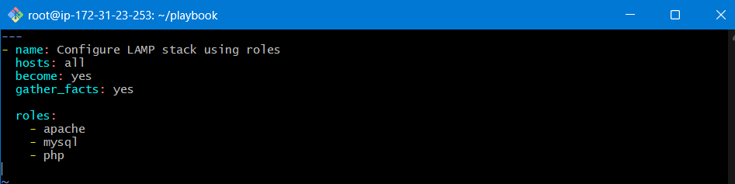
Executes roles in this order:
  - apache – installs & starts web server
  - mysql – installs & starts database server
  - php – installs PHP packages

Step 6: Syntax Check
From lamp/ directory:
ansible-playbook site.yml --syntax-check
Step 7: Run the Playbook
ansible-playbook site.yml
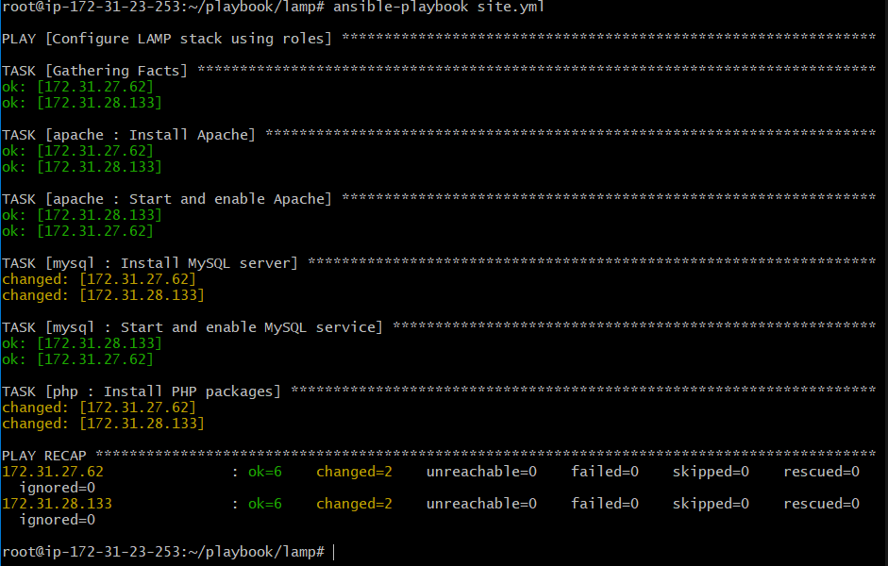
Step 8: Verify LAMP Stack
Check services
systemctl status apache2 # Ubuntu
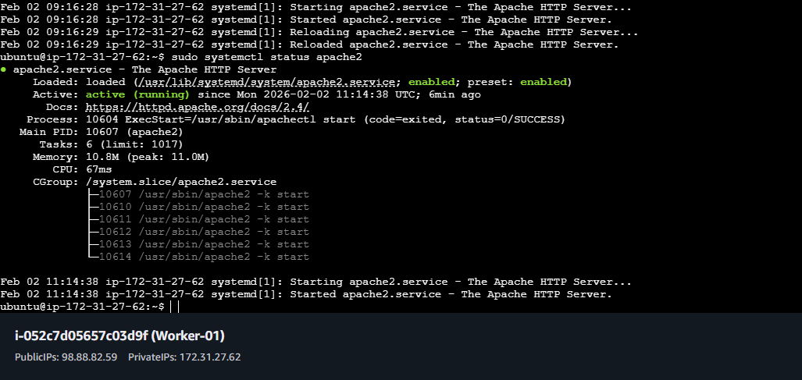
systemctl status mysql
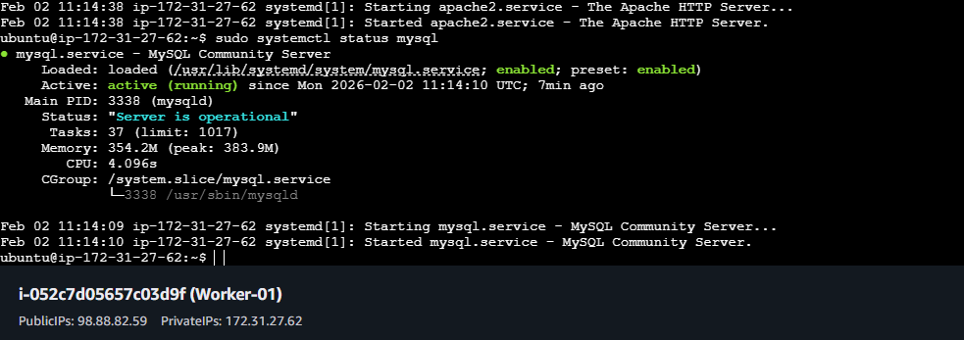
php -v

Test PHP Page
echo "<?php phpinfo(); ?>" > /var/www/html/info.php
Open in browser:
http://<server-ip>/info.php
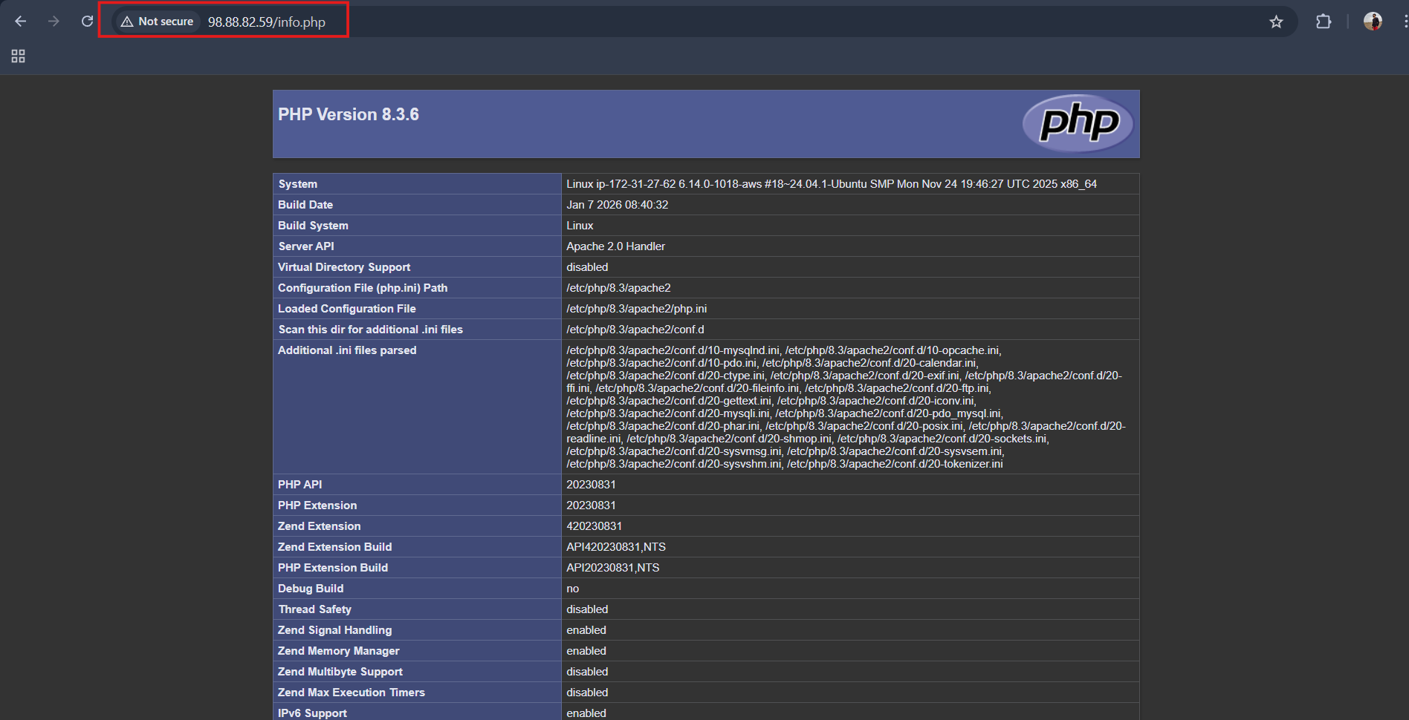

- Setup ansible AWX and explore the options.
Step 1: Prepare the Server
Launch an instance with t2.large instance type and 20 gb ebs volume
AWX runs in Docker / Podman / Kubernetes, so you need a modern Linux machine with at least 4GB RAM
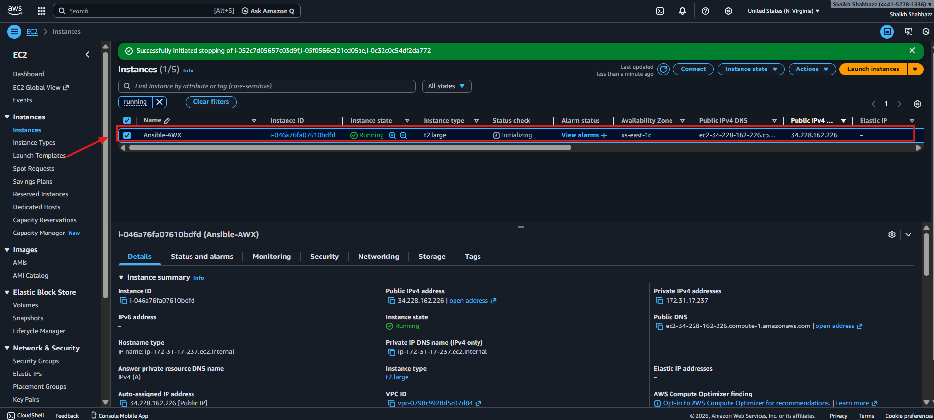
# Update system
sudo apt update -y
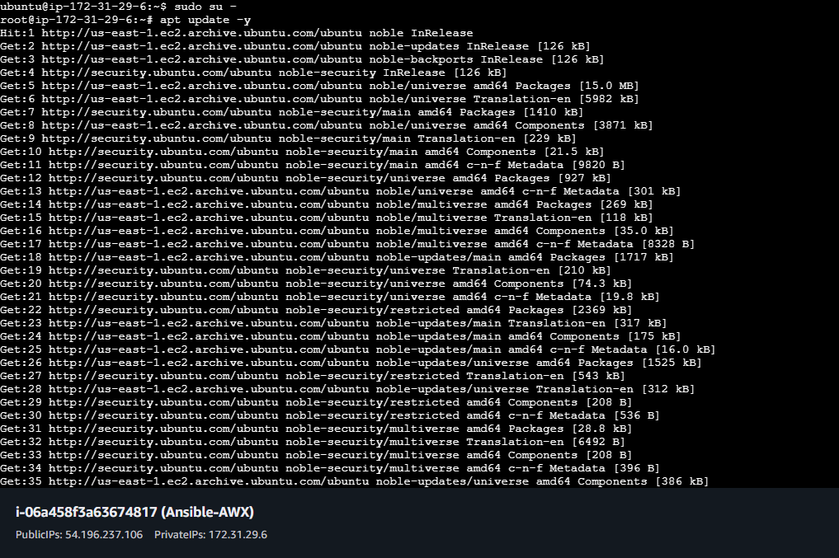
# Install required packages
apt install ansible -y
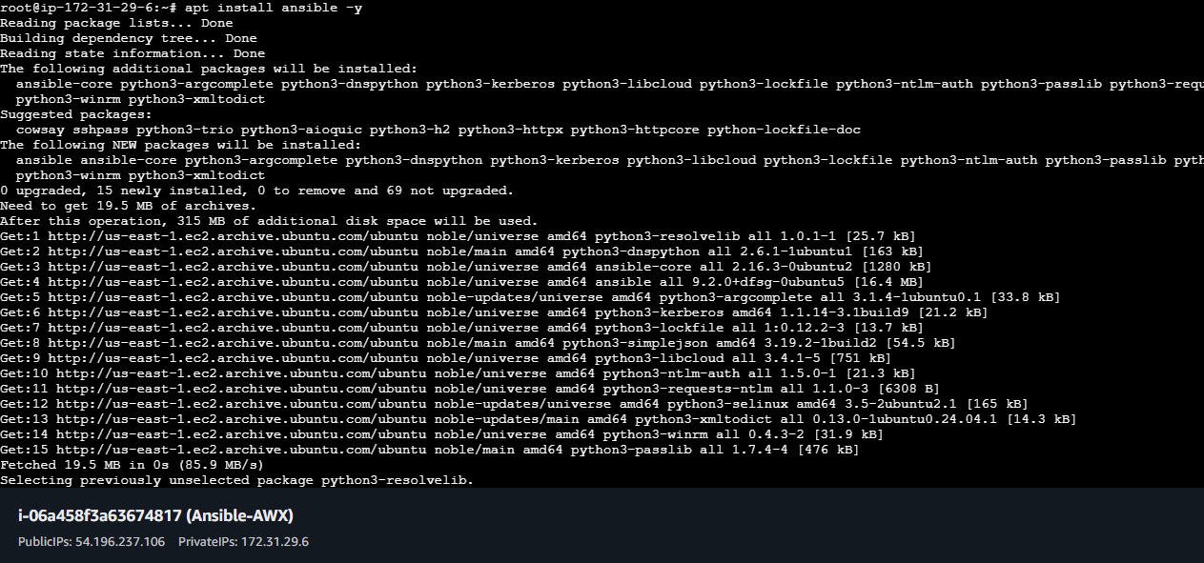
Step 3:Install Required Packages
apt install docker.io -y
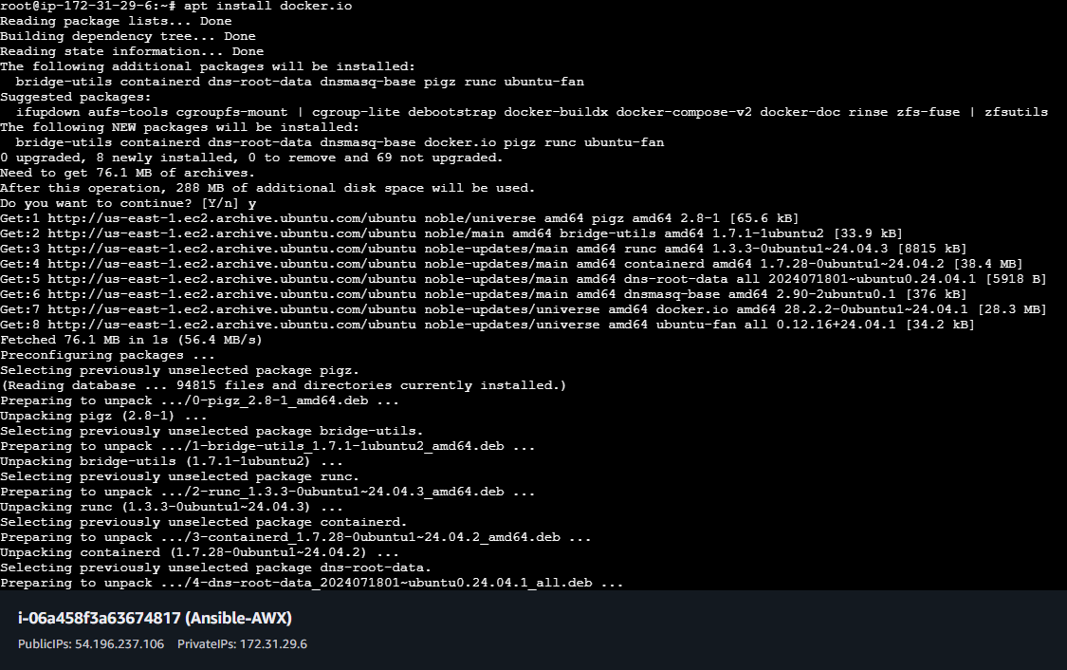
# Start docker service and check for status
sudo systemctl start docker
sudo systemctl status docker
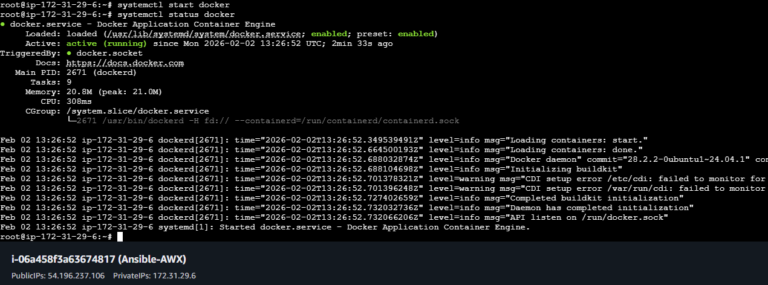
# Enable and start Docker
sudo systemctl enable --now docker
sudo usermod -aG docker $USER # allow non-root Docker usage
#Install Docker Compose
apt install docker-compose
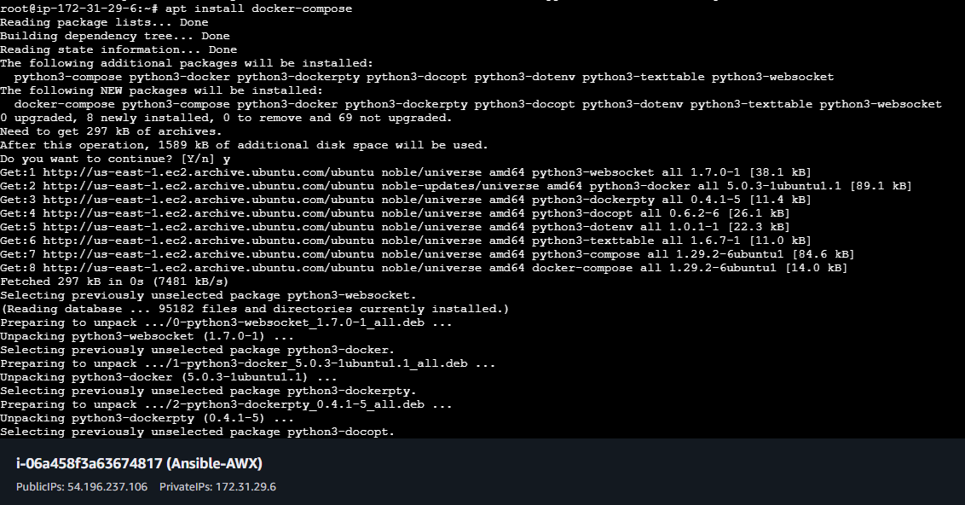

Step 2: Clone AWX Repository
cd ~
git clone -b 17.1.0 https://github.com/ansible/awx.git
cd awx
ls
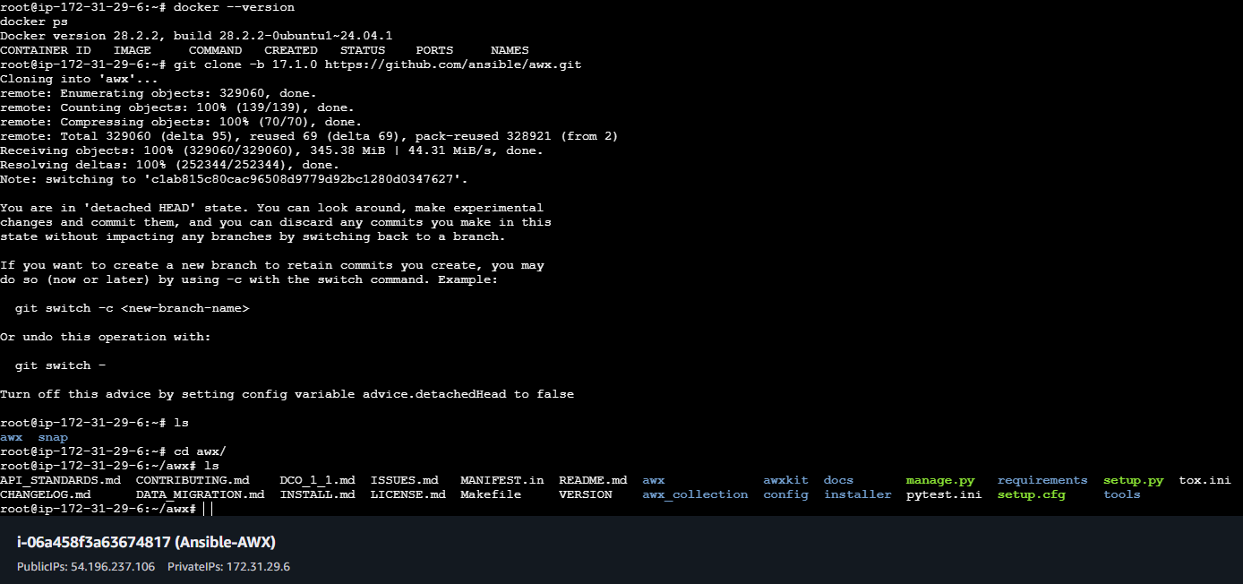

# Edit the ~/awx/installer/inventory file and uncomment the lines as shown below
cd awx/installer/inventory
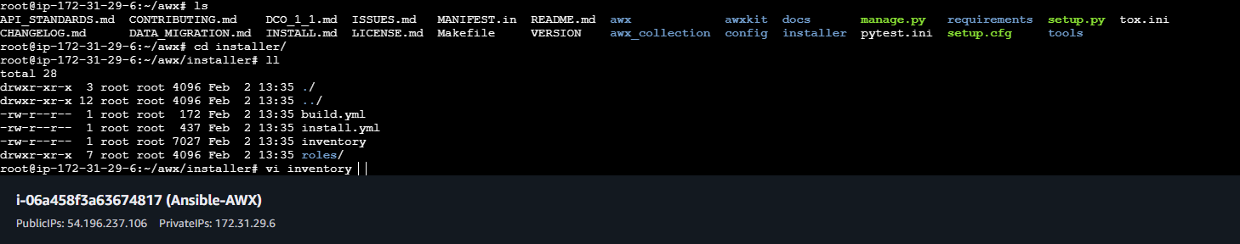
admin_password=Admin@123
secret_key=Admin@123
pg_database=awx
pg_password=Admin@123
awx_alternate_dns_servers="8.8.8.8,8.8.4.4"
postgres_data_dir="/var/lib/awx/pgdocker"
docker_compose_dir="/var/lib/awx/awxcompose"
project_data_dir="/var/lib/awx/projects"
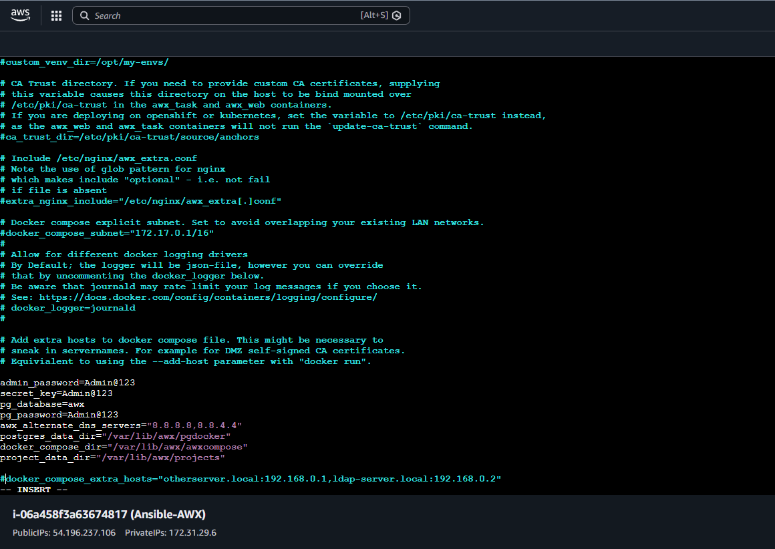
Step 3: Install AWX using Docker Compose
3.1 Navigate to installer directory
cd installer


3.3 Run the installer
# Install AWX by running the Ansible Playbook
ansible-playbook -i ~/awx/installer/inventory ~/awx/installer/install.yml
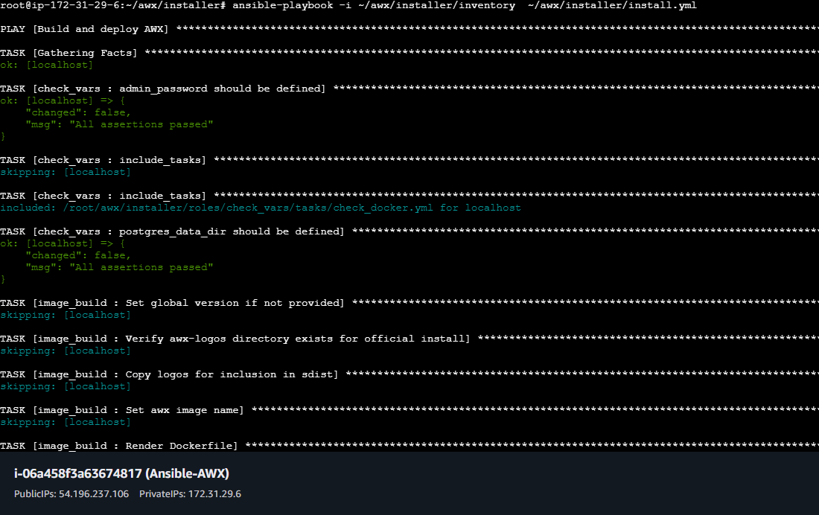
#It will take some time to start
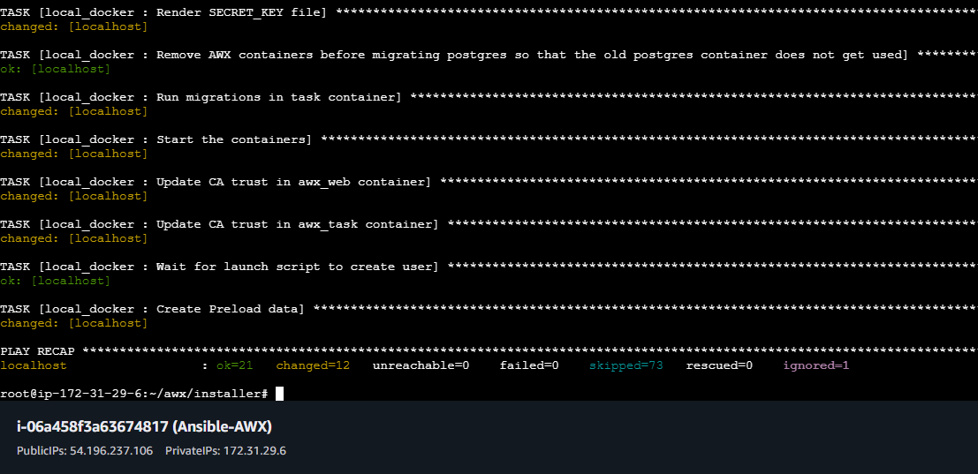
Step 4: Access AWX Web UI
- Open browser:
http://<AWX_SERVER_IP>
- Login with admin credentials
Username: admin
Password: Admin@123

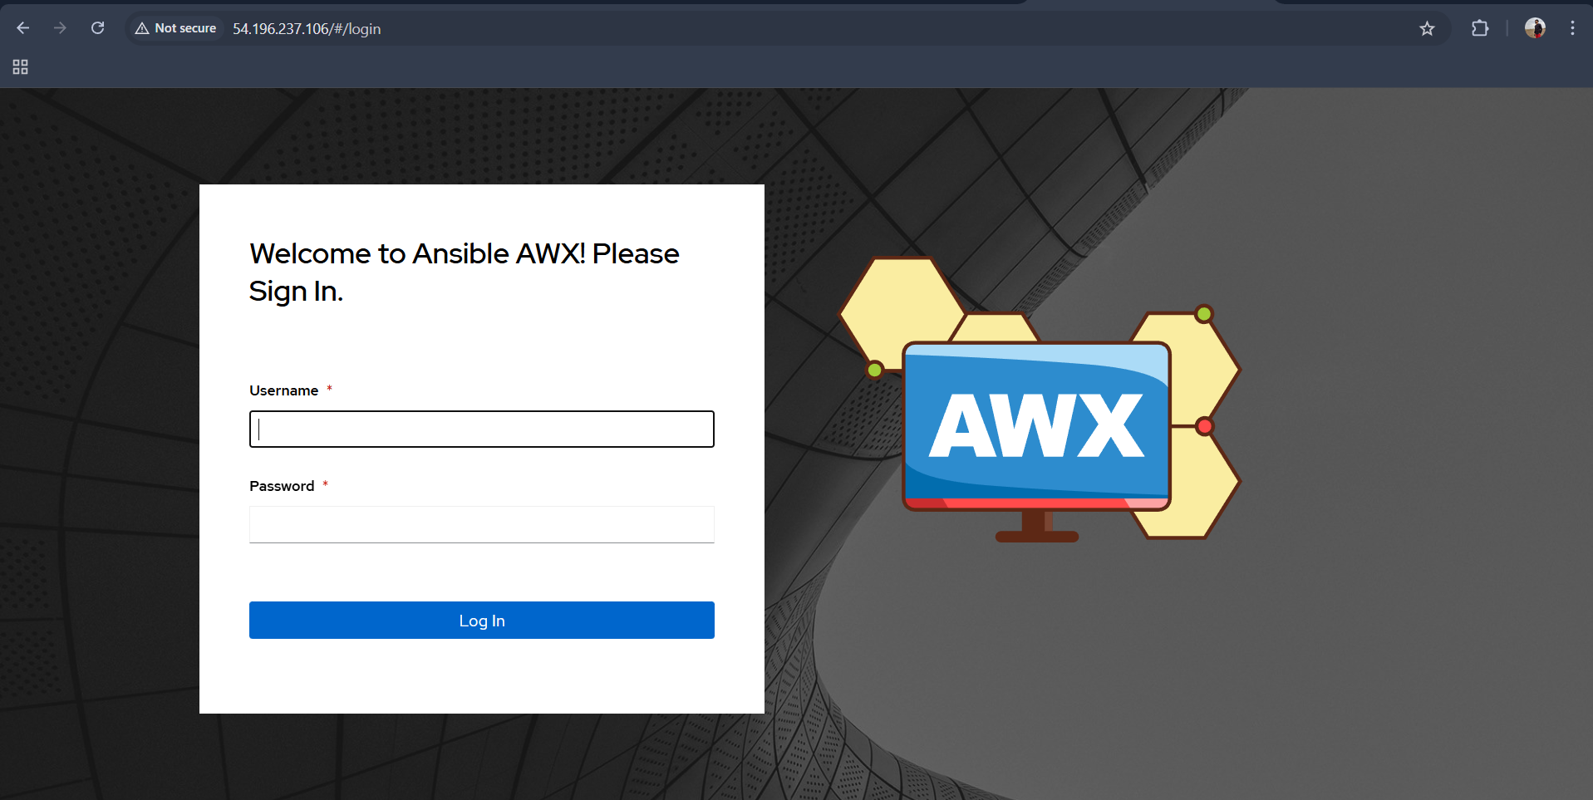

- You will see dashboard:
  - Projects – Git repos with playbooks
  - Templates – Job Templates
  - Inventories – Hosts & groups
  - Credentials – SSH keys, Vault secrets, cloud keys
  - Organizations / Teams / Users – RBAC control
  - Jobs – Run your playbooks
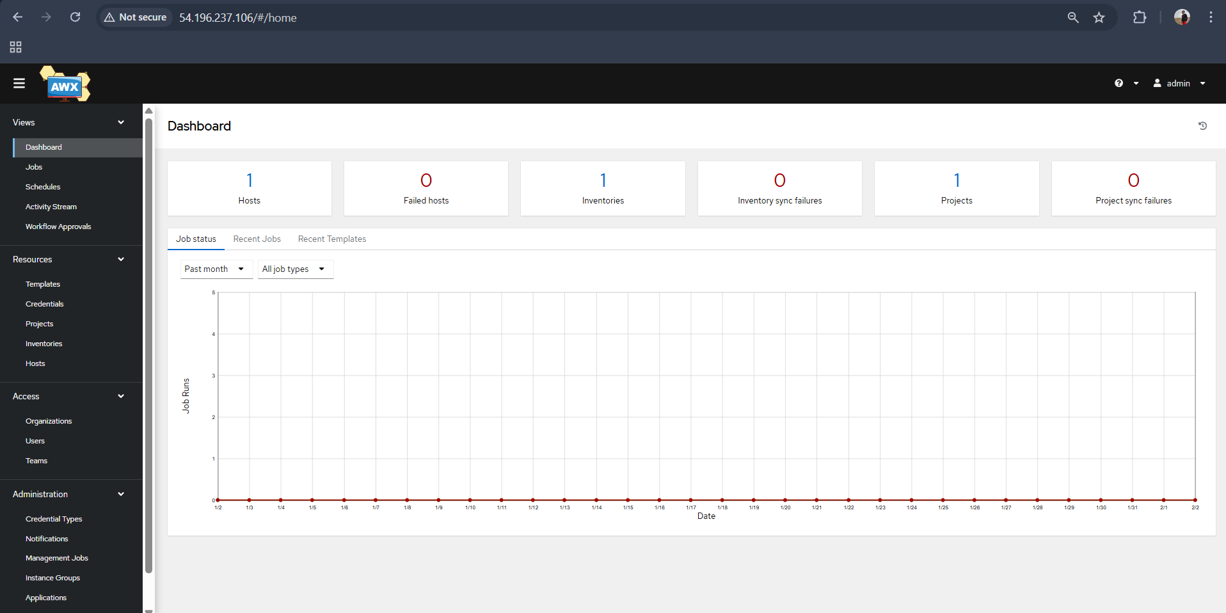

Verify:
docker ps
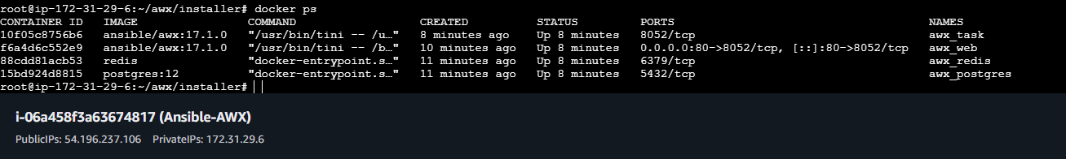

STEP 1: Create Inventory (NO HOSTS HERE)
You already did this part correctly.
Inventory details:
- Name: local-inventory
- Organization: Default
- Variables: ❌ LEAVE EMPTY
👉 Click Save
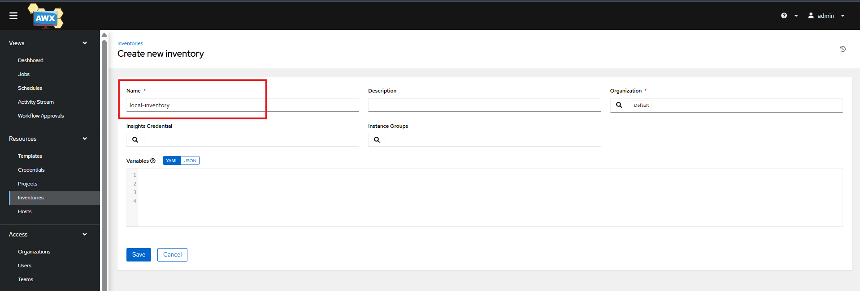
STEP 2: Add Host to Inventory (IMPORTANT)
After saving inventory:
- Go to Inventories
- Click local-inventory
- Go to Hosts tab
- Click Add
Fill details:
- Host Name: localhost
Variables (THIS is where it goes):
ansible_connection: local
Click Save
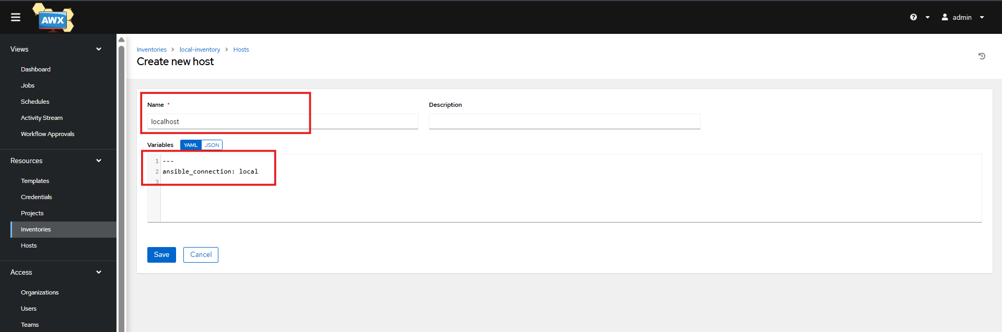

STEP 3: VERIFY INVENTORY IS CORRECT
Go to:
- Inventories → local-inventory → Hosts
You should see:
localhost
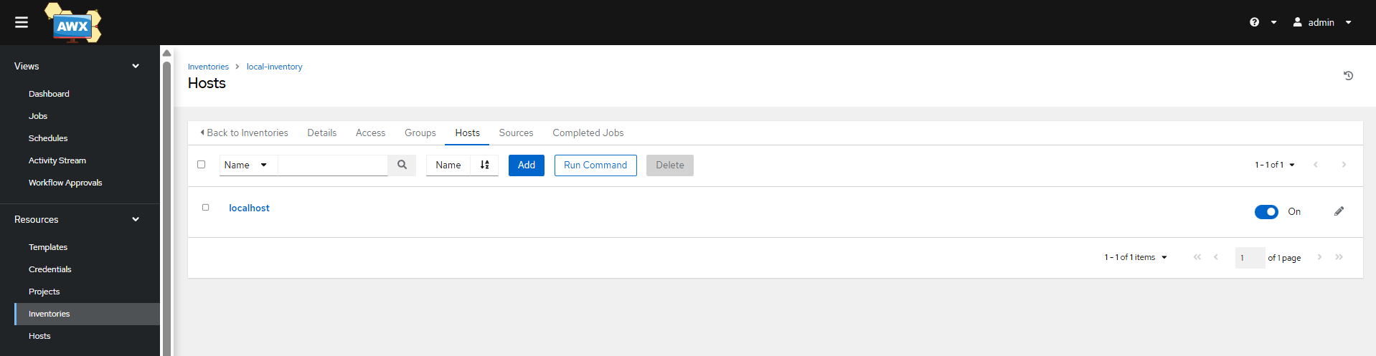
STEP 4: RUN A TEST JOB (FINAL VALIDATION)
Create Project
- SCM Type: Git
- URL:
https://github.com/shaikhshahbazz/practice.git
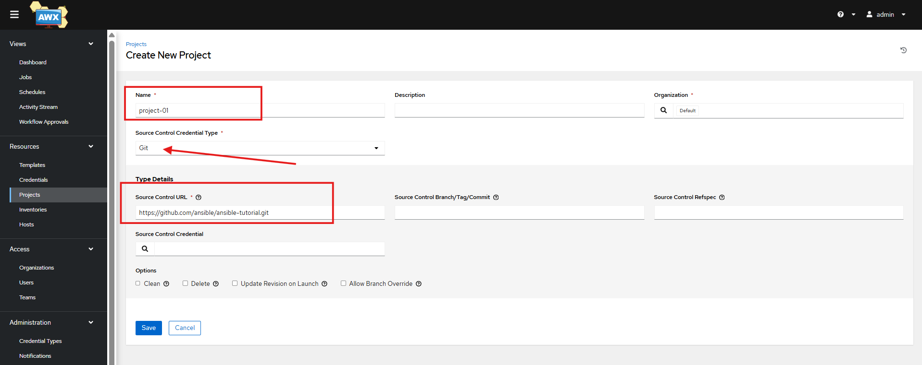
Click sync and wait until it turns green
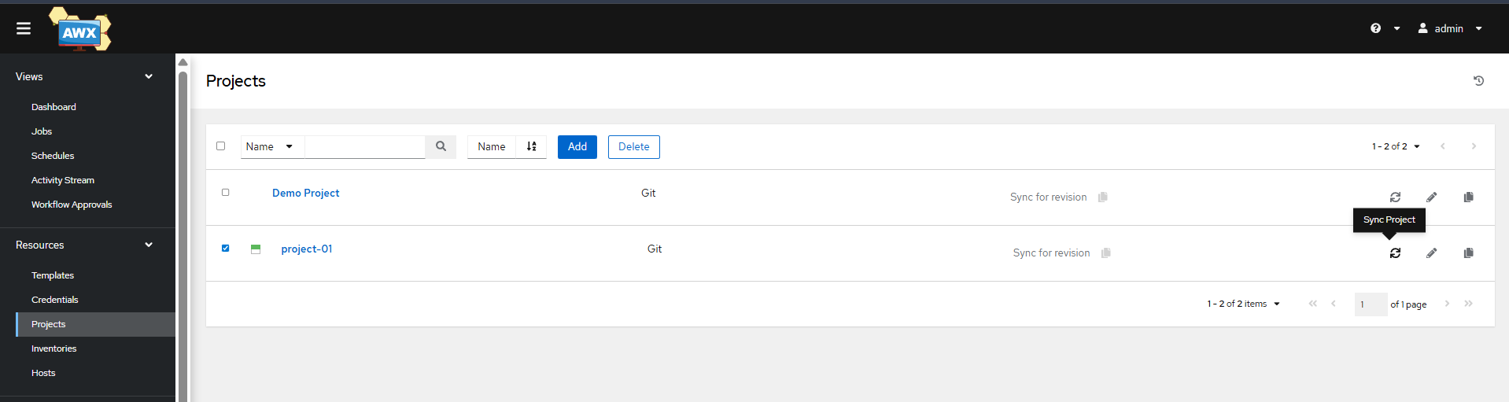
Create Job Template
- Inventory: local-inventory
- Project: ansible-tutorial
- Playbook: ping.yml
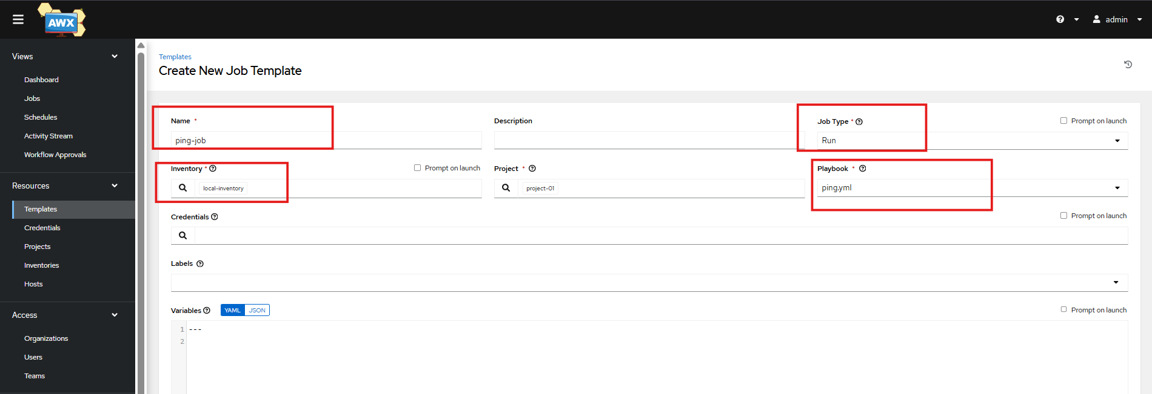
Launch 🚀
Expected Output:
localhost | SUCCESS => pong
AWX is fully functional
